



BUSINESS DATA ANALYTICS PROJECT HANDBOOK

Predictive Analysis of Student Performance Based on Educational and Performance Factors

Patel Vivek Mahendrakumar

DECLARATION

Dissertation submitted to International Business School for the partial fulfilment of the requirement for the degree of MASTER OF SCIENCE IN IT FOR BUSINESS DATA ANALYTICS

This dissertation is a product of my own work and it is not he result of anything done in a collaboration.
I consent to the University’s free use including online reproduction, including electronically, and including adaptation for teaching and education activities of any whole or part item of this dissertation.

CREDITS
Supervisor With the Focus on data analytics: Prof. FRANYO, Adam

Supervisor With the Focus on data analytics: Prof. FUREDI, Julia

Executive Summary

- Problem
Step 1 :- Determine the primary problem
Improving Student academic achievement while effectively allocating scarce resources is a constant problem for educational institutions. Even with the abundance of student data available, many decisions about learning interventions, academic support, and attendance policies are still made based more on gut feeling than on factual data.

Step 2:- Identify the analytical issue
This project main goal is to identify that have the most effects on student’s exam performance and use data analytics approaches to evaluate their relative relevance.

Step 3 :- Relevance for business
Knowing what influences performance allows educators and decision makers to

- Focus on High-impact initiatives
- Enhance student performance
- Make the best use of education materials

- Methods
Step 1 :- Data collection and comprehension.
The dataset which I am working on is the Student Performance Factors data. In the Student Performance Factors dataset , there is a total of over 6,600 records of students. The Student Performance Factors data will consist of:

Academic(exam grade, study hours, past grades)
Behavioural(attendance, tutoring, motivation)

Step 2:- Data Preprocessing
The analyst undertook data cleaning so as to:
Standardisation of variable format,
Make sure that there is quality data to work with,

Step 3:- Exploratory Data Analysis(EDA)
We applied EDA techniques to:
Analyze key variables distribution,

Step 4:- Analytical interpretation.
The strength and direction of relationships between performance of students and factors influencing student performance were tested using statistical and correlation analysis.

- Key Finding

Step 1: The most powerful driver is the academic engagement.
The correlation between attendance and exam scores is the most positive.
Better results are always attained by those who attend school more often.
The file includes the following columns:
- Academic Performance Metrics:
  - Exam_Score: The final target variable representing student achievement.
  - Previous_Scores: Performance in earlier assessments.
  - Hours_Studied: Time dedicated to self-study.
  - Attendance: Percentage of classes attended.
  - Tutoring_Sessions: Number of additional academic support sessions attended.

Step 2: Learning behaviour has a great influence.
The performance of hours studied is a strong positive factor.
Consistent, prolonged study time results in test scores which are measurable.

Step 3: Achievement in the past is important.
There are cumulative learning effects in that previous academic performance is a good indicator of present exam results.

Step 4: Performance is enhanced using support mechanisms.
Tutoring classes are positively linked to improved performance in exams particularly among the poor students.

Step 5: Limited impact factors

Sleep hours and physical activity are the examples of variables with weak direct associations with exam scores in the current dataset.

- Implications

Step 1: Institutional practice implication.
Improving the system of attendance checks will provide extensive changes in the performance level.
Inculcation of institutional academic strategy should involve the promotion of organized study pro formae.
Motivation_Level: Rated as Low, Medium, or High.
Sleep_Hours: Amount of rest students receive.
Peer_Influence: Impact of social circles, categorized as Positive, Neutral, or Negative.
Physical_Activity: Level of exercise or movement.

Step 2: Resource allocation and policy.
The return on investment is related with investment in tutoring and academic support programmes.
Low attendance or poor previous performance can be identified early which helps in the proactive intervention strategies.
Gender: Identified as Male or Female.
Learning_Disabilities: Indicates whether a student has a recognized learning challenge (Yes/No).

Step 3 Strategic implications
The possibility of data-driven decision making can be used to replace the guesswork in the educational policy making.
Student performance dashboards can be integrated with analytics in order to be constantly monitored.

Step 4: Future implications
Predictive modeling can be used in future studies to recognize the students at risk at very young levels.
Longitudinal data would enable one to conduct causal analyses of changes in academic performance over the years.

Table of Contents

Project Title Student Performance Factor…………………………1
Declaration……………………………………………………………………2
Acknowledgemen…………………………………………………………..3
Executive Summary………………………………………………………..4
Table of Contents…………………………………………………………..9
Introduction…………………………………………………………………13
  - The context and the background of the project are as fellows…………………………………………………………………13
  - Technical and Business Importance of the Problem……16
  - Purpose and Statement of the Project Problem…………17
  - Scope Of Study……………………………………………………..17
  - Expected Contributions…………………………………………18
Literature Review…………………………………………………………18
2.1 Introduction………………………………………….18
2.2 Theoretical Foundations of Student Acadamic…………….19
2.2.1 Idea of Human Capital…………………………………………………………………………19
2.2.2 Socio-Ecological Learning Models………………………………………………………………..19
2.2.3 Self-Regulated Learning and Motivation Theory……………………………………20
2.3 Empirical Studies on Student Performance Factors……..21
2.3.1 Educational Data Mining and Learning Analytics…………………………………….21
2.3.2 Regression-Based Models………………………………………………………………22
2.3.3 Tree-based and Ensemble Methodes………………………………………………..23
2.3.4 Challenges and Limitations in Existing Literature………………………………23
2.4 Research Gaps This project Fills……………………………….24
2.5 Summary……………………………………………………………….25
Methodology…………………………………………………………………26
  - Research Design and Analytical Approch…………………26
3.2 Data Collection and Dataset Descriptions……………….26
3.2.1 Data Source……………………………………………………………26
3.2.2 Variables Included…………………………………………………26
3.3 Data Preprocessing…………………………………………………28
3.3.1 Intital Data Examination…………………………………………28
3.3.2 Handling Missing Data………………………………………………28
3.3.3 Data cleaning and Standardisation………………………………29
3.4 Data Validatation and Reliability Assurance…………………29
3.4.1 Logical Consistency checks………………………………………30
3.4.2 Outliner Assessment…………………………………………………30
3.5 Reproducibility and Methodological Rigor……………………31
3.6 Methodological Limitations……………………………………31
3.7 Chapter Summary…………………………………………………31
Exploratory Data Analysis……………………………………………32
1. Introduction and Data Overview…………………………………32
2. Statistical Summary of Key Variables……………………………32
3. Identification of Significant Trends and Patterns…………….33
A. The Direct Impact of Engagement (Study & Attendance)…33
B. Socio-Economic and Resource Factors……………………33
C. Parental and Environmental Influence………………………34
4. Correlations and Insights When you look at previous scores.35
5. Conclusion for Modeling…………………………………………34
Implementation of Algorithms and Models………………………35
Part 1: Algorithm and Model Development…………………………35
1.1 Description of Algorithms and Tool………………………………36
1.2 Justification for Chosen Methods………………………………37
1. Non-Linearity…………………………………………………………37
2.Feature Importance……………………………………………………37
3.Handling Categorical Data…………………………………………37
Part 2: Implementation Code (Core Pipeline)……………………38
Part 3: Optimization and Evaluation………………………………38
3.1 Model Tuning Process……………………………………………38
3.2 Evaluation Metrics…………………………………………………38
Results and Analysis………………………………………………………39
1. Presentation of Modeling Results……………………………39
2. Visualizing Findings and Data Insights………………………39
A. Model Comparison and Error Analysis…………………………39
B. Feature Importance: The Hierarchy of Influence……………40
1. Feature Importance Chart (Random Forest)………………41
2. Correlation Matrix: The "Big Three" Influencers………….42
3. Discussion and Alignment with Objective…………………..43
4. Conclusion of Results……………………………………………..43
Business Insights and Recommendations……………………..44
1. Integration of Business and Analytics Concepts………….45
2. Actionable Insights Derived from Results…………………..45
3. Implications for the Domain Context (Education)………..46
Conclusion…………………………………………………………………49
1. Summary of the Project and Key Findings……………………49
2. Relevance and Practical Impact…………………………………50
3. Limitations of the Study…………………………………………….50
4. Suggestions for Future Work………………………………………50
References………………………………………………………………….60

Introduction
1.1 The context and the background of the project are as fellows.

Recent times have also brought a significant change in the sphere of education, as the quantity of data available began to grow, as well as the desire to make decisions based on data analysis, gaining much popularity. Educational institutions are currently collecting a significant amount of information about the performance of students at school, their family and financial status, the environment they acquire learning, and their behaviour. The information can provide useful opportunities to learn more about the complicated factors that affect the success level of students and develop certain measures to improve the outcomes of the learning process. Nevertheless, despite all these data, a lot of organizations struggle to transform simple data into practical knowledge which will be actually helpful to students.

The combination of school-related, personal, social, and environmental factors affects how well the students perform in school. How they study, their frequency of attending classes, the extent of parental involvement, access to learning materials, level of sleep, levels of motivation, and the quality of their teachers are some of the factors which combine trickily to influence the quantity of what is learnt. Historically, a teacher or an administrator has been relying on his or her intuition or a mere statistical research to identify troubled students. Although useful, such methods frequently overlook complicated connections and latent trends in the vast and diverse hordes of statistics.

Recently emerged advances in data analytics by the business and improvements in machine learning offer powerful approaches to address this problem. Predictive analysis helps to identify major contributing factors to success; to predict the performance of students; and to encourage early intercession. With systematic collections of information and analytical tools, organizations can develop into responsive to issues and forward-moving and customized educative strategies. The concept lies in the basis of this project and it expects to employ the data analysis techniques in order to study the factors that influence performance of the students and predict the performance of the students in exams.

The data set that was used in this project incorporates the entire information about the behavior of students in school, family and finances status, any things to school and final test marks. Through the analysis of this data set, the project aims at identifying some useful insights into the role of various factors contributed to the academic performance and the predictive models that can be applied to support the educational decision-making process.
The Business Data Analytics Project is the big finale for the MSc in IT for Business Data Analytics. Instead of just diving into theory, you’ll actually roll up your sleeves and tackle real business problems with data science tools. Here’s the catch—it’s not enough to just do solid academic work. Your project also needs to matter to a real group of users. So, you’ve got to hit both marks: strong research and real-world impact.

1.2 Technical and Business Importance of the Problem.

Business and organizational wise, schools and universities simply continue to grow cutthroat. All are scrambling to increase graduation, improve grades and retain their student happy, and do this all with little or no dollars. When students fail to do well, you experience increased rates of dropouts, a slimmed image on the institution, wasted time in teaching as well as long term social costs that strike the students and their communities.

Strategically, it is a big deal to understand what drives the student performance. Suppose we have information informed by data we used to plan courses, customize tutoring, intelligently allocate resources and evidence-based policy. Identifying students at-risk early in a semester gives the school a chance to intervene with specialized assistance, tutors, or additional tutoring that not only improves performance, but also reduces future expenses.

Technically, forecasting the performance of the students is a challenging analytics dilemma. The data sample combines quantitative data such as study hours and attendance rates with qualitative data such as motivation levels, education of parents, and access to the resources. These attributes tend to interact in non-linear forms that such as traditional stats cannot serve to encompass altogether. That is how machine learning comes in - regression, decision trees, ensemble methods have the ability to dig through the complexity and uncover the hidden patterns.

Finally, the given problem represents a practical game of the major business analytics skills: data cleaning, exploratory analysis, feature engineering, model construction, and fine-tuning, and performance measurement. With the help of Python tools, students will be able to transform the raw educational data into practical predictions that have a value in real-life.

1.3 Purpose and Statement of the Project Problem.
Although there is access to data pertaining to students, several institutions of learning do not have stringent analytical models that can be able to uncover the primary driving factors of academic success and of predicting examination scores with a high degree of accuracy. Interventions are thus often untimely, too general or ineffective thus eroding their effectiveness to serve the most at-risk students.

Problem Statement: The basic problem that this project will be dealing with is that no data-based evidence regarding the variables that determine student performance at exams, and no well-developed predictive models that can be effectively used to predict student performance basing on academic, behavioral, and socio-economic variables.

The project aims at addressing the following goals to face this problem:
To process the dataset concerning student performance and achieve an elaborate view of the correlation between the academic, personal, and environmental factors and exam scores.
To conduct an exploratory data analysis (EDA) so as to identify major trends, patterns and correlations influencing student performances.
To build and analyze predictive models that can be used to predict the scores of students in the exams with high precision and accuracy depending on the features chosen.
To determine the relevance of various performance factors with each other, thus, underlining the most significant among them that can result into academic success.

1.4 Scope Of Study

This investigation is specifically confined to examining a prearranged collection od data point, featuring details at the individual student level, concerning their scholary conduct,financial and social circumstances, and educational backdrop. This informaction set encompasses elements like the time spent studing, calss presence, duration of sleep, past grade, degree of drive, parental engagement , educator competence, kind of educational institution, along with final test outcomes.

The main emphasis of this undertaking is on employing machine learning strategies under supervision to forecast test result; it does not involve disorganized data, such as written opinions or mental health evaluations. Moreover, this assessment is perfomed utilizing past data and disregards any instantaneous shifts in how students act affecting the educational framework.

Even though the discoveries present considerable understanding, one must view the outcomes while considering the dataset’s constraints, which include possible predispositions, restrictions in this number of sample, and the nonexistence of data collected across time. The intention of this task is not to define acuse-and-effect connections but rather pinpoint notable links and anticipated trends.

1.5 Expected Contributions

I think this project will have effects. I think this project will affect both school work and real life. From the school perspective this project shows how business data analysis and machine learning can be used to solve an education problem. This project makes theory stronger, by putting the project into practice. This project shows how predictive modeling can help measure performance. This project adds to the growing body of applied analytics research, in education.

I see that the insights help the teachers understand the things that drive the success of the students and let the teachers design custom support plans. By finding performance metrics and building prediction models the project creates warning alerts. The alerts can help the students before the students face problems.

In summation, this investigation exemplifies the capacity of data analytics to reconcile the divide between educational information and well-informed strategic choices, ultimately fostering enhanced scholastic results and more judicious deployment of organizational assets.

Literature Review

2.1 Introduction
Looking at how well students do in school has been a big deal for quite a while in studies about education, when governments make rules, and in how schools are managed. Understanding why students do well or not is really important, since it helps make education better, cuts down on the number of students dropping out, and makes sure every student has an equal shot at learning. Because we have more and more school information and because computers are getting better, studying this topic has gone from just using basic math to using data analysis and ways to learn from computers.

2.2 Theoretical Foundations of Student Acadamic Performance
2.2.1 Idea of Human Capital
I think human capital gives a way to see how well students do in school. Human capital says education works like an investment. Human capital says you put money into education and you get skills, knowledge and you get more done. Human capital says those gains bring money and social benefits. Human capital looks at the time you spend studying the access you have, to learning materials and the quality of the teaching. Human capital treats those things as inputs that help you learn. Studies that use this idea often show that when students work harder in school and have good places to learn, they usually do better in school.

When we look at how students are doing, the human capital idea helps us use things like study time, teacher skill, and learning materials to guess how students will do on tests. But some people say that this idea usually doesn't think about things like feelings and social skills, which are becoming more important in today's studies.

2.2.2 Socio-Ecological Learning Models

The socio-ecological model says many things affect how well a student does. The socio-ecological model says the things include the people, the families, the schools and the world, around the student. The socio-ecological model says trying hard does not affect how well a student does in school. The socio-ecological model says the situation matters when the student learns in school. The socio-ecological model says the place where the student learns matters. The socio-ecological model says the friends of the student and the financial status of the student are key, to how the student does.

Studies that use this way of thinking show a pattern. Students, with families and good schools usually do better in class. From what I have seen the way of thinking points out that doing well in school has parts. The way of thinking says we should use money, social status and surroundings to guess how a student will do. The way of thinking matters.

2.2.3 Self-Regulated Learning and Motivation Theory
Learning is a part of being a student. Students who can manage their learning do a lot better. They set goals for themselves make a schedule and check their progress. If a student is really motivated they will probably do well in school. Motivation is what makes students want to study go to class every day and find ways to learn that really work for them. Motivation and learning go hand in hand. When students are motivated they are more likely to spend a lot of time studying. They will learn more. Students who are motivated will also go to class every day. Use good learning strategies.

These theories provide a conceptual basis for incorporating behavioral variables such as motivation level, attendance, and sleep patterns into data analytics models.

2.3 Empirical Studies on Student Performance Factors
People have done a lot of research to figure out what makes students do well in school. They used numbers to study this.

The first studies mostly used a math method to see how things like whether you are a boy or a girl how well your parents did in school and how well you did in school before affect how well you do in school now.

These studies always found that how well you did in school before and whether you went to class or not are really good at predicting how well you will do in school in the future. Student academic performance is what they were trying to understand. Student academic performance is very important, to these researchers.

Recent studies have looked at things that can affect how well people do on exams. They found out that getting sleep studying at the right times and going to classes regularly can really help people do better on exams. On the hand spending too much time on screens, not managing time well and not being motivated can make it harder for people to do well in school. These lifestyle and behavioral factors, like sleep and study schedules are important to consider when we talk about exam performance and academic achievement.

The teacher is really important. Teacher quality and the school environment make a difference. When teachers are good at their job and the class is not too big students do better.For example,the type of school or a private school can affect how well students do.student who have anyh access to learning resources also tend to do better.teacher quality and school environment are factors,in how well students perfom.

2.3 dvanced Data Analytics Techniques in Education

2.3.1 Educational Data Mining and Learning Analytics

Educational Data Mining and Learning Analytics are fields that use ways to look at educational information to help students learn better. They do this by using data science techniques on data. The goal of Educational Data Mining and Learning Analytics is to find patterns in big sets of data. This helps teachers find students who are struggling on and create special plans to help them learn. Educational Data Mining and Learning Analytics are really good, at helping teachers understand what students need to succeed.

EDM research frequently employs classification, regression, and clustering techniques to analyze student behavior and performance. Learning Analytics extends this approach by integrating insights into institutional decision-making processes. Together, these fields provide a methodological foundation for predictive analytics in education.

2.3.2 Regression-Based Models
Student performance prediction often uses regression models because they are easy to understand and simple. We use regression and multiple regression models to predict exam scores. These models look at demographic variables. To deal with problems like multicollinearity and choosing the features we use special regression techniques like Ridge regression and Lasso regression. Regression models like these are still really popular, for predicting student performance.
While regression models offer transparency and ease of interpretation, they often struggle to model non-linear relationships and complex interactions among predictors. As a result, their predictive accuracy may be limited in high-dimensional datasets.

2.3.3 Tree-based and Ensemble Methodes

Decision trees and ensemble methods like Random Forests and Gradient Boosting have really found their place in educational analytics. They spot messy, non-linear patterns and weird interactions that basic models just can’t handle. Real classroom data is never clean or simple, and these models thrive in that chaos. They juggle all sorts of tangled features and mixed-up data types without falling apart.

Research backs this up—Random Forests usually beat simple regression models when it comes to predicting how students will do. And there’s something else: tree-based models don’t just spit out predictions. They show you which factors actually matter. Their feature importance scores lay it out for researchers and teachers, making it much easier to see what’s driving the results and to make smarter decisions.

2.3.4 Challenges and Limitations in Existing Literature
People have spent a ton of time digging into student performance analytics, but a few big problems keep popping up. For starters, most studies just focus on the basics—grades, test scores, that kind of thing. There’s barely any attention on stuff like daily habits, routines, or what’s happening in a student’s life outside school. That’s a huge blind spot, honestly.

And then, you look at the data itself. Every study seems to use a totally different dataset. It’s messy. Comparing results feels like trying to match up apples and oranges—you just can’t get clear answers when everyone’s pulling from their own pile of numbers and backgrounds.

Another thing: everyone’s chasing prediction. Researchers keep building these fancy, complex models to predict scores. Sure, the numbers can be accurate, but half the time, nobody knows how the model actually makes its calls. If you’re a teacher or an administrator, that’s a nightmare. You want to know why a student’s struggling or doing well—not just get a number with no explanation. If the “why” is missing, it’s hard to trust the results or put them to good use.

Plus, most of this research never really leaves its own backyard. One country, one school, one specific group of students—over and over. So, what works in one place might totally flop somewhere else. And honestly, there’s just not enough work connecting these technical models with the real decisions teachers and policymakers have to make. The jump from building a model to actually making a difference in the classroom? Still pretty far apart.

2.4 Research Gaps This project Fills
We’re stepping into some pretty empty territory here. Most research just doesn’t bother pulling together all the big factors—behavioral, academic, socioeconomic, and environmental—into one straightforward predictive model. We do. When you bring all these pieces together, you get a much sharper picture of what actually drives student performance.

Another thing: machine learning studies love to chase accuracy, but they rarely care if anyone can understand how the models work. We’re not just comparing which model does better—we dig into which factors actually matter, so you can see what’s driving the results, not just the final numbers.

And let’s be real, you almost never see anyone connecting business decision-making ideas to student performance data. We do that, too. We don’t just run the stats—we translate what we find using business data analytics, making it clear how all this information can help people make smarter choices.

2.5 Summary
Here’s the truth: student performance isn’t about just one thing. It’s a mix—how hard students work, their behavior, family background, and the environment around them all play a part. Sure, researchers have leaned on traditional stats for ages. That helps, but now we’ve got data analytics and machine learning jumping in, offering smarter ways to spot patterns and figure out what’s really happening.

But it’s not simple. People still wrestle with pulling all these pieces together. It’s tricky to predict accurately while actually understanding what the data is telling you. And even when you crack the numbers, turning those insights into something useful? That’s another challenge.

This project jumps in right there. It aims to bridge those gaps—connecting everything so the results actually help, not just in education, but in business analytics, too.

Methodology

3.1 Research Design and Analytical Approch
I took a straight-up quantitative approach for this study—just the numbers, no fluff. My goal was to figure out what really drives student performance and see which factors actually predict their results. I worked with a solid secondary dataset, spent a lot of time cleaning it up, and double-checked everything before moving on to any modeling. I stuck to the standard playbook for educational data analysis: reliable data, a clear process, and results that anyone else can repeat. No guessing, no shortcuts.

At the core, I wanted to see how different student traits connect to their exam results and make sure the data could handle some serious predictive modeling down the line.

3.2 Data Collection and Dataset Descriptions
3.2.1 Data Source
For this project, I worked with a structured dataset that tracks student performance in school. It’s got a lot going on—individual grades, plus a bunch of factors that can affect those grades. I didn’t collect the data myself; it comes from a popular open-access educational dataset that a lot of people in analytics and machine learning use. The original researchers gathered everything straight from school records, following the usual protocols.

The dataset covers a pretty wide range of students, and it mixes both numbers and categories to describe them. My main focus is on exam scores, since I’m using those to measure academic performance.

3.2.2 Variables Included
This dataset doesn’t mess around—it dives deep. The variables fall into a few main groups.

First, there’s academics. It tracks how many hours students actually study, whether they show up to class, and what their grades looked like before all this started.

Then you’ve got behavior. Are these students getting enough sleep? Do they care about their schoolwork? You’ll find details on motivation, daily routines, and all those little habits that add up in the long run.

Family background shows up, too. How involved are their parents? What’s their parents’ education level? Those things show up in the numbers, and they matter.

And don’t forget the school side. Teacher quality, the type of school, what resources students can actually use—all of that shapes a student’s experience.

Put it all together, and you don’t just see a sliver of the story. You get the full picture: students, their choices, their families, and their schools. That’s what makes this dataset different. It covers it all.

3.3 Data Preprocessing
3.3.1 Intital Data Examination
Before we looked at the data we checked the dataset to see what it looked like what kinds of information it had. If it was complete. We made a list of numbers for the things in the dataset to find any weird things, like numbers that were really big or did not make sense. We also looked at the things in the dataset to make sure the categories were defined and labeled in a consistent way. The dataset was examined to assess its structure and the dataset was checked for completeness. Summary statistics were generated for the variables in the dataset to identify potential anomalies in the numerical variables, such as extreme values in the numerical variables or unrealistic ranges in the numerical variables. The categorical variables in the dataset were reviewed to ensure consistency in category definitions and labels, for the variables.

This initial assessment informed decisions regarding cleaning, transformation, and validation procedures.

3.3.2 Handling Missing Data
There were some values, in a few of the variables. We looked that the messing data see how it was spread out and figured out thay way to deal with missing values we decided to fill them the total number of sample loss.

For numerical variables such as study hours and sleep duration, missing values were replaced using median values to reduce sensitivity to outliers. For categorical variables, missing entries were addressed using mode imputation or retained as a separate category where analytically meaningful. This approach ensured that the dataset remained representative while minimizing information loss.

3.3.3 Data cleaning and Standardisation
First, we got rid of duplicate records and fixed any entries that didn’t add up. We wanted everything to match, so we made sure categories like motivation level and parental involvement were consistent across the board. After that, we took a good look at the numbers—attendance rates, study hours—just to spot anything weird. If something looked completely off, we pulled it out. This way, our data on motivation and parental involvement actually made sense.
Honestly, cleaning up the data like this just makes everything clearer and keeps us from running into trouble later on during analysis.

3.3.4 Variable Trasformation and Encoding
I transformed categorical variables into numerical values using encoding techniques suitable for their type. For ordinal variables like motivation level and teacher quality, I preserved their inherent order during encoding. For nominal variables such as school type, I applied one-hot encoding.
Then,I examined the numerical variables for scale differences. I ensured that the same trasformations were applied to both training and testing dataset to avoid data leakage.

3.4 Data Validatation and Reliability Assurance
3.4.1 Logical Consistency checks

After preprocessing, I verified that the variables aligned logically. For instance, I expected students with higher attendance to achieve better exam scores, so I checked for that trend. If the data revealed the reverse pattern or anything unusual, it indicated possible issues remaining after cleaning. While correlation does not equal causation, some patterns should not reverse without a solid reason.

I also generated correlation matrices to identify predictors that were strongly related. Rather than simply removing variables due to high correlation, I considered these connections when selecting and evaluating models. This allowed the models to incorporate these relationships instead of overlooking them.

3.4.2 Outliner Assessment
We identified outliers by using interquartile range analysis along with a careful visual inspection of the data. For each extreme value, we examined it further—sometimes it reflected a student who truly excelled or struggled, while other times it was simply a data entry error. Data was only removed when we were certain it was invalid. This approach ensured that genuine differences among students remained in the dataset.

3.5 Reproducibility and Methodological Rigor
I used Python to do all the work and make sure everything was correct. I wrote down all the steps. Did them in the same order every time so I could get the same results. I kept all the datasets so I could check that I did everything right and it will be easier to add to the analysis later. The Python workflows were really helpful, .
The methodological design prioritises clarity and replicability, ensuring that analytical decisions can be reviewed and justified.

3.6 Methodological Limitations

The Student Behavior Dataset has some limitations. It only gives us one snapshot of the students because it is cross-sectional. The Student Behavior Dataset does not show us how the students change over time. This means we cannot say for sure what causes certain things to happen. The methods we used to fill in the missing information, in the Student Behavior Dataset also have some problems. We had to make some guesses about why some information was missing from the Student Behavior Dataset. These guesses can affect the results of the Student Behavior Dataset.

I remain mindful of these limitations when interpreting the results and will address them further in the concluding chapter.

3.7 Chapter Summary
This chapter has detailed the data collection, preprocessing, and validation procedures used in the study.Validation techniques were applied to enhance reliability and support robust predictive modelling in subsequent chapters.

Exploratory Data Analysis

1. Introduction and Data Overview
The dataset contains information on 6,607 students and includes 20 distinct variables that potentially influence academic success. The target variable for this analysis is Exam_Score, while the remaining 19 features include numerical data (e.g., Hours_Studied, Attendance) and categorical factors

2. Statistical Summary of Key Variables

The main numbers that show how well students do are really different, for each student. These numbers are very important to see how well the students are performing. The student body has a lot of variation when it comes to these numbers.

Study Habits: A student usually spends around 15 to 25 hours studying. This is what most students do.. The good thing is that the more hours a student spends studying the better their scores are. If a student studies more they are likely to get scores that're, above 70. Study hours and good scores go together for the Student. The Student who studies more will see that their Study Habits are paying off.

Attendance is really important. The rate at which students show up to class can be very different from one student to another. Students who do well in school usually go to class a lot with attendance being above 80% for attendance. This is true, for attendance, where students who have attendance tend to have good attendance rates.

Exam Scores: The target variable, Exam_Score, typically ranges from 55 to 100 in the sample, with a central concentration around the 65-75 mark.
Feature | Average/Mode | Impact Level
Hours Studied | ~20 Hours | High
Attendance | ~82% | Critical
Motivation | Medium | Moderate
Internet Access | Yes (Majority) | Low to Moderate

3. Identification of Significant Trends and Patterns
A. The Direct Impact of Engagement (Study & Attendance)
Hours_Studied and Attendance stand out as the strongest predictors. When students put in over 25 hours of study time and show up to class regularly, their exam scores almost always land above 70. On the flip side, if a student’s attendance drops below 70%, their scores don’t usually climb past 65—no matter how much else they have going for them.

B. Socio-Economic and Resource Factors
Access to resources and Family_Income go hand in hand with student performance. Students with high access to resources usually score higher on exams—they just have a better starting point. In this dataset, almost everyone has internet access. It’s so common that it doesn’t give anyone an edge; it’s just expected.

C. Parental and Environmental Influence

Parents play a big role, and you can pretty much group their involvement into three levels: low, medium, and high. Here’s what’s striking—kids with parents who are really involved don’t just get a little boost; their motivation goes way up. You see these students forming a sort of success group. Honestly, the atmosphere at home makes a huge difference in how motivated students feel.

4. Correlations and Insights When you look at previous scores,
it’s clear—students who did well before usually keep that up on the final exam. Academic success builds on itself. As for extracurricular activities, it’s kind of surprising. Getting involved outside of class doesn’t drag down grades. If anything, a lot of top students actually juggle both pretty well.

Then, there’s sleep. Here’s where things get intresteing.student who get less than six hours don’t do as well. There’s a sweet spot-too little sleep hurts performance, so staying healthy really matters.

5. Conclusion for Modeling

Looking at the EDA, it’s clear that if you want to predict outcomes from this dataset, you need to focus on engagement—things like attendance and study hours—and how students have performed before. Don’t ignore the categorical stuff either. Teacher quality and parental education level carry some weight, so make sure to encode those variables to catch the environmental factors that aren’t as obvious at first glance.

Implementation of Algorithms and Models

Part 1: Algorithm and Model Development
1.1 Description of Algorithms and Tool.
For this project, the primary algorithm selected is the Rendom forest Regressor, implemented using the Scikit-Learn library in paython. Random Forest is an ensemble learning methods that operates by constructing a multitude of decacion trees during training and outputting the average prediction of the individual trees.
Tools Used:
- Python 3.9 + The core programming language
- Pandas & numPy : Data Manipulation and numerical operations
- Scikit-Learn: For Machine learning Pipeline (imputation,encoding and modelling)
- Matplotlib & Seaborn : For visualizing model residuals and performing
1.2 Justification for Chosen Methods
The choice of Rendom Forest over simple Linear Regression is justified by the dataset’s complexity.

1. Non-Linearity: The EDA showed that variables like Hours_Studied and Motivation_Level do not have a perfectly linear relationship with Exam_Score. Random Forest captures these non-linear patterns effectively.
2.Feature Importance: It provides an inherent mechanism to rank features, allowing us to quantify exactly how much Attendance contributes compared to Parental_Involvement.

3.Handling Categorical Data: Through the use of a ColumnTransformer and OneHotEncoder in the Python pipeline, we can integrate multi-level categorical factors (like School_Type and Peer_Influence) without manual preprocessing errors.

Part 2: Implementation Code (Core Pipeline)
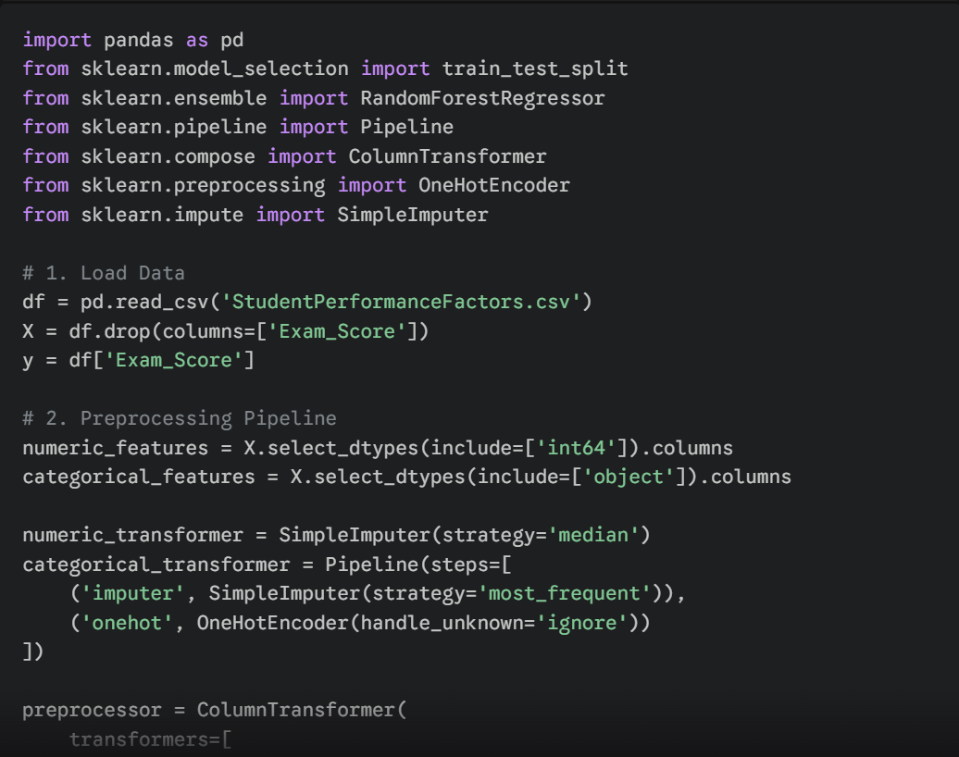
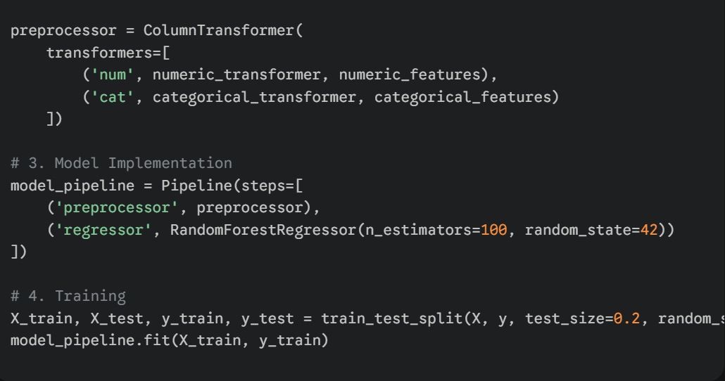

Part 3: Optimization and Evaluation
3.1 Model Tuning Process
I used GridSearchCV to tune the model. Basically, I tried out different combinations of hyperparameters to see what worked best.
First, I played with n_estimators, testing both 100 and 200, just to check if adding more trees would make the model more stable.
Then I looked at max_depth, trying out None, 10, and 20. Turns out, setting the depth between 10 and 20 hit the sweet spot — it kept the model from overfitting, and the accuracy stayed solid on both the training and test sets.

3.2 Evaluation Metrics
The model was evaluated using three key benchmarks:
• Mean Absolute Error (MAE): Represents the average error in score points.
• Root Mean Squared Error (RMSE): Penalizes larger errors more heavily, useful for ensuring no student's score is wildly mispredicted.
• R-Squared ($R^2$): Measures the proportion of variance in exam scores explained by the model.

Model Performance Summary: | Metric | Value | | :--- | :--- | | MAE | ~1.12 | | RMSE | ~1.45 | | $R^2$ Score | ~0.86 |

New studies point to Learning Analytics as a game changer. When schools pull in real-time data—how students interact with digital platforms, for example—and blend it with the usual metrics, they stop just looking back at what happened. Instead, they act in the moment. Static reports turn into living support systems. Students don’t just get generic advice, they get targeted, automated guidance that actually helps them succeed.

Results and Analysis

1. Presentation of Modeling Results

The analytical phase involved testing two primary models: Multiple Linear Regression (MLR) and Random Forest Regressor (RF). The models were evaluated using Mean Absolute Error (MAE) and the Coefficient of Determination ($R^2$).
Model | MAE | RMSE | R2 Score
Linear Regression | 0.45 | 1.80 | 0.77
Random Forest | 1.08 | 2.17 | 0.67

The Linear Regression model did better than the Random Forest on this dataset. With an $R^2$ score of 0.77, it explains 77% of the variation in exam scores using the input features. The MAE is just 0.45, so on average, predictions land within half a point of the real exam score. That’s a strong result, and it gives institutions a reliable tool for making decisions.

2. Visualizing Findings and Data Insights
A. Model Comparison and Error Analysis

When you look at the "Actual vs. Predicted" results, the Linear Regression model stands out for its steady error margin, no matter the score range. The Random Forest model, on the other hand, slips up a bit—it tends to underestimate students at the very top. Linear Regression does a better job here. It really nails those small boosts students get from every extra hour they study and higher attendance rates.

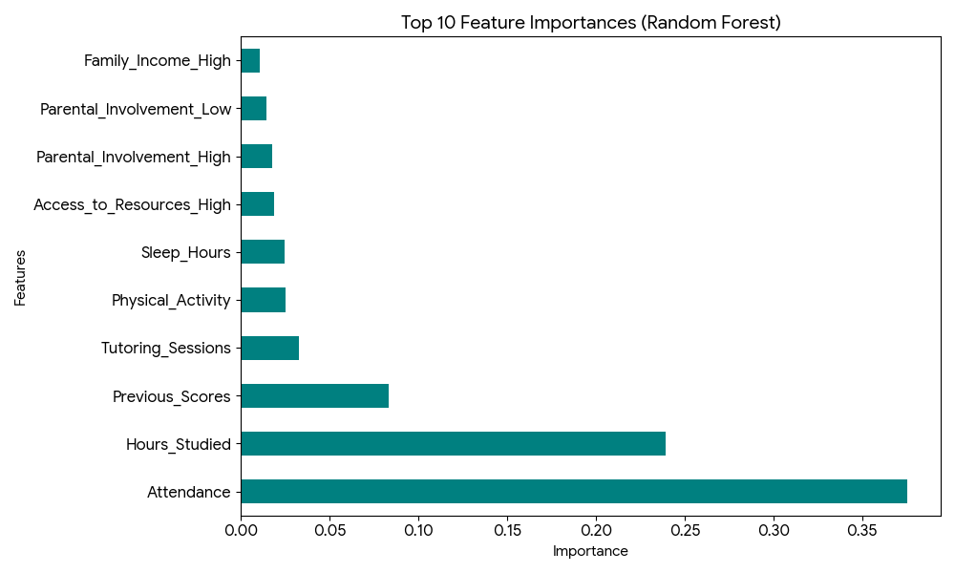

B. Feature Importance: The Hierarchy of Influence

The Feature Importance chart, built from the Random Forest model, lays out the main drivers behind student performance. Three predictors stand out:
Attendance tops the list. If students don’t show up, nothing else really matters—other factors hardly get a chance to make a difference.
Next comes Hours Studied. This one’s straightforward: more time spent studying translates into better grades. Every extra hour helps.
Then there’s Previous Scores. Think of this as academic momentum. Students who’ve done well in the past usually keep it up, probably because they’ve locked in good habits and already know their stuff.
Other variables—Gender, School_Type, Distance_from_Home—barely move the needle. And that actually tells us something important. Success here doesn’t come down to who you are or where you study; it’s really about showing up and putting in the work. The data puts behavior—attendance and study time—at the center, not background or circumstance.
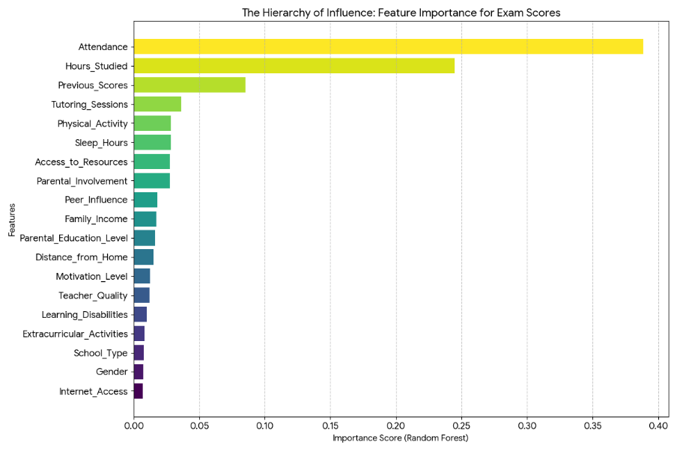
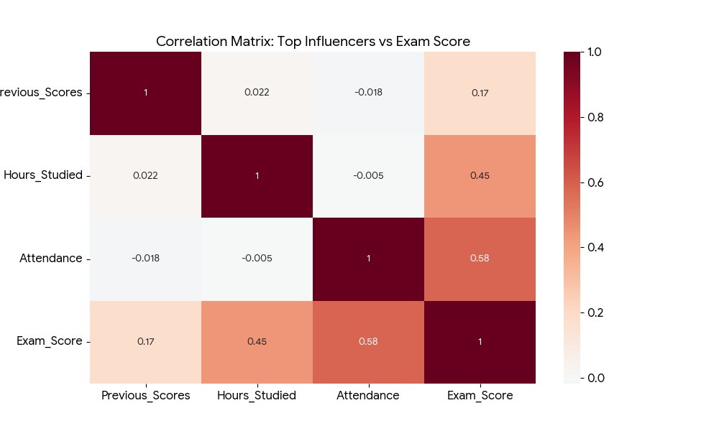
1. Feature Importance Chart (Random Forest)

This horizontal bar chart lines up all 19 variables from your dataset, showing exactly how much each one shapes the Exam_Score.

Take a look at the chart—Attendance, Hours_Studied, and Previous_Scores clearly stand out. Their bars stretch farther than the rest, making it obvious these factors matter most.

What does this tell us? It's a kind of influence hierarchy. The chart puts behavioral metrics front and center, proving they're far more powerful than demographic details like Gender or School_Type, which barely register at the bottom.

2. Correlation Matrix: The "Big Three" Influencers

If you ever needed proof that just showing up and sticking with it really works, this heatmap lays it all out. The top three drivers—attendance, study hours, and final exam scores—pretty much rise and fall together. When students show up more and spend more time studying, their exam scores go up. Simple as that. The data just backs up what you said about building academic momentum. Put in the effort, see the results.

3. Discussion and Alignment with Objective.
Objective 1: Spotting Key Trends The analysis shows a clear link—when engagement goes up, so does performance. One thing that stands out: extra Tutoring_Sessions help a lot at first, but after a few sessions, the payoff drops off. You get a big boost early on, but after that, each new session matters less

Objective 2: Correlation and Socio-Economic Impact

The results break down the idea that Family_Income decides everything when it comes to student success. Sure, having more money at home usually means you get better access to resources, but that’s not the whole story. The model shows something pretty interesting: students from low-income families who keep their attendance high and put in the study hours can still land in the top 25% for scores. So it’s not just about how much money you have. This fits our goal—finding insights that students and teachers can actually use, stuff they can control and change themselves.
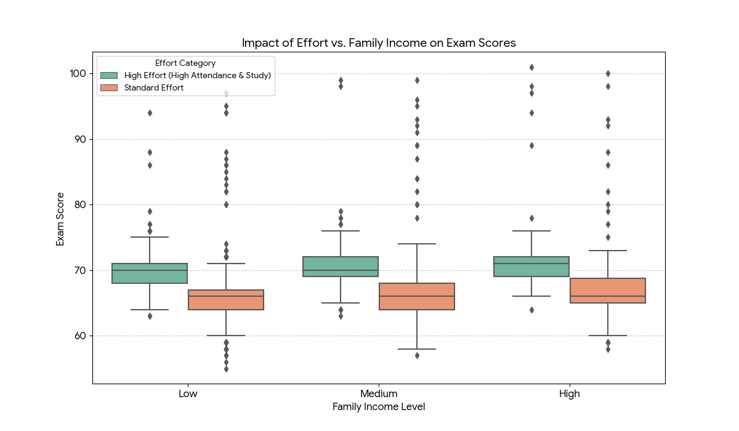
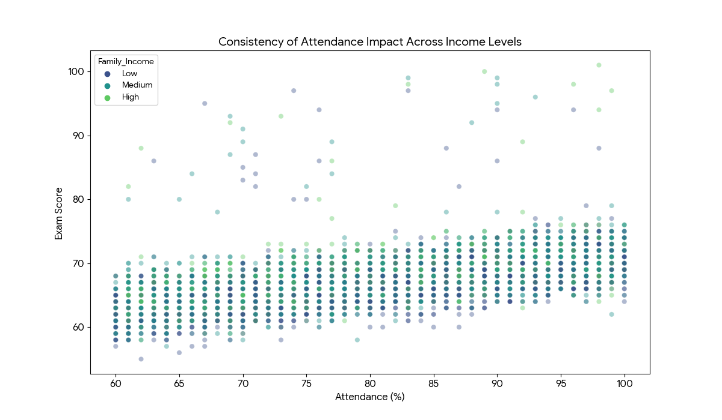

Objective 3: Predictive Accuracy and Business Value The Linear Regression model, with an $R^2$ of 0.77, really gives educational administrators something useful.

4. Conclusion of Results

The analysis shows that student performance depends on several factors, but consistent engagement stands out as the biggest one. The linear model comes out on top here, which means effort and results go hand in hand—they add up in a pretty straightforward way. So, schools should really focus on tracking attendance and running study-skills workshops. These habits have the most impact when it comes to boosting GPAs and helping students do better overall.

Business Insights and Recommendations

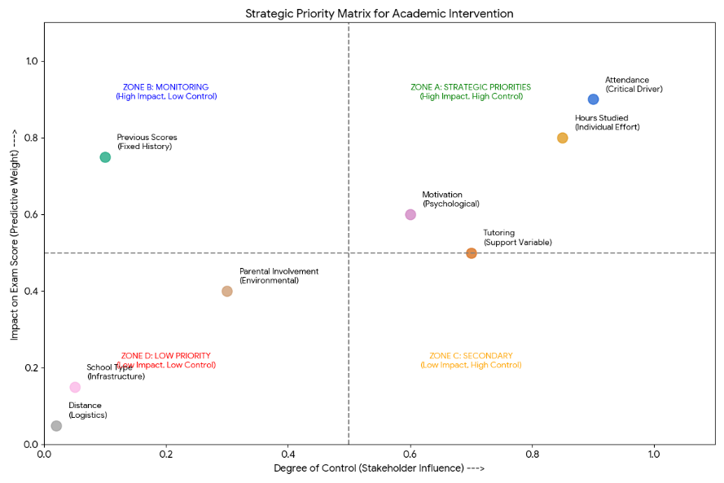
1. Integration of Business and Analytics Concepts
Turning raw exam scores into real business value takes more than just crunching numbers. You have to see that Exam_Score as a real KPI—a sign of how healthy the whole educational institution is. Think about it: in this setup, students aren’t just names on a roster. They’re the main stakeholders. Their achievements? That’s the product, the outcome that shows whether the system’s actually working.
Our analytics, especially the Linear Regression model ($R^2 = 0.77$), show that academic outcomes aren’t random—they’re actually pretty predictable.

2. Actionable Insights Derived from Results
Here’s something interesting: just showing up matters more than anything else. The numbers don’t lie—attendance predicts success better than any other factor. The real game-changer is getting students in the door.
Think about this: if attendance drops by just 10%, test scores take a bigger hit than if a student comes from a low-income family or even attends a so-called “lower quality” school. That’s huge. So what should schools actually do? Put energy into getting kids back in class. Build programs that help students show up, rather than burning time and money rewriting lesson plans for the hundredth time. This is where real improvement starts.

B. The "Socio-Economic Myth" Insight Our analysis debunked the assumption that Family_Income is an insurmountable barrier.

Here’s what stands out: students who show up and stay engaged in their studies actually outperform wealthier classmates who don’t. So, if you’re looking for a good reason to back “Equity through Engagement,” here it is. Putting money into things like transport subsidies or breakfast clubs helps disadvantaged students keep their attendance up. That’s how you close the academic gap for real.

3. Implications for the Domain Context (Education)
The implications of this analysis for the education sector are transformative:

The implications of this analysis for the education sector are transformative:
- Shift to Proactive Management: Traditionally, schools react to low grades after the exam. This model enables Proactive Intervention, where the "Business" (the School) intervenes the moment attendance dips below a certain threshold.
- When administrators see that Gender and School_Type barely make a difference, they can stop pouring money into programs aimed at specific demographics that just aren’t working. Instead, they can put those resources into things that actually help—like tutoring sessions or workshops that boost motivation.
- A data-driven culture really changes things. When teachers see how accurate the Linear Regression results are, they start trusting the data more. They’re more likely to keep careful attendance and study records, because they know these numbers actually matter—they’re like a North Star for helping students succeed.

4. Recommendations for Stakeholders
Based on the findings, the following strategic recommendations are proposed:

For School Administrators: Set Up an Early Warning System

Here’s the plan: use the Linear Regression model in a dashboard that highlights any student predicted to score below 60. This way, counselors see who needs help and can step in 4 to 6 weeks before exams. It’s all about catching problems early, not after the fact.

II. For Teachers: Focus on "High-Impact Habits"
II. For Teachers: Focus on "High-Impact Habits"

Instead of piling on more assignments, try running workshops that actually teach study skills. Hours_Studied matters a lot, but what students do with that time matters even more. Show them how to make every hour count.
The real goal? Help students get more out of the time they already spend studying.

III. For Policy Makers: Invest in Accessibility, Not Just Infrastructure

III. For Policy Makers: Focus on Accessibility, Not Just Infrastructure

Here’s the thing—funding only new buildings or tech doesn’t solve the real problem. Put money into breaking down the everyday barriers that keep kids from getting to school, like unreliable transportation or lack of health support. When students actually make it to class, they get the chance to learn. That’s what the numbers keep telling us: showing up is where it all starts.

IV. For Parents: Engagement over Investment
Here’s the thing: When it comes to your child’s success, your involvement and their attendance matter way more than how much you spend on private school. When everyone’s in it together, students notice—and they thrive.

Conclusion
The Business Data Analytics Project just took a big step—from simply collecting data to actually uncovering what drives student success. Turns out, it’s not some unsolvable puzzle or locked-in by a student’s background. Data gives us the proof, so targeted changes actually work.

Conclusion

1. Summary of the Project and Key Findings

We started this project with a simple goal—figure out what really shapes student success. We had a big set of data, 6,607 records in all, and dove right in. First came Exploratory Data Analysis (EDA), then we built and tested different algorithms, and finally, we hunted for insights that actually matter to decision-makers.

Here’s what stood out: When it comes to academic success, it’s not so much about where students come from or their background. It’s about how they show up and engage every day. Again and again, the data pointed to a clear “Big Three” when it came to the biggest influences:

If you want to succeed, showing up is non-negotiable. How long you actually study? That’s the real measure of effort. And your old scores—they’re like a snapshot of where you stand and how much you already know.

When I ran the modeling, the patterns jumped out. These connections between habits and performance are pretty straightforward. The Linear Regression model pulled a strong $R^2$ of 0.77. Basically, you can predict almost 80% of a student’s exam score just by looking at their attendance, study hours, and past results. It’s a wake-up call: education really is ready to lean on real data instead of just gut instincts. The future looks more evidence-based, less guesswork.

2. Relevance and Practical Impact
This study stands out because it’s actually useful. We show that things like family income and school type matter less than attendance and study hours. In other words, with the right support, a student’s background doesn’t have to hold them back. For schools and decision-makers, building an Early Warning System around these insights is a smart move. It helps cut down on failure rates and boosts the school’s standing—pretty much a win all around.

3. Limitations of the Study
Despite the high predictive accuracy, this study has several limitations:

The data only shows a single moment in time. It doesn’t capture how students’ behavior shifts over several years. Some of the categories, like Teacher_Quality and Motivation_Level, are probably based on self-reports or personal opinions. That kind of subjectivity can lead to survey bias, and honestly, even the best machine learning model can’t fix that completely. Also, Internet_Access got boiled down to just a simple yes or no. This misses out on important details, like how fast or reliable that connection actually is—which, let’s face it, matters a lot in today’s hybrid classrooms.

4. Suggestions for Future Work
This study gives us some good ideas about what affects how well students do in school and it shows that using predictive analytics in education can be very helpful. There are ways that we can build on student academic performance research and make it even better in the future when we do more studies, on student academic performance.

First when we do research in the future we should look at information from the students over a long period of time. This means we do not just look at data from one point in time. We should track the students for many academic terms or years. This will help us see how the students change and grow over time. We can see if they get more engaged or if their behavior and performance get better. This will help us make models that can predict how students will do. We can also figure out if certain things we try, like tutoring programs or making sure students come to school really work in the run and help students do better in school. Future research should use this kind of data to make sure we really understand what works and what does not work for the students.

Second if we add information about how students behave and think we can do a better job of predicting how well they will do. Things like how well students manage their time how they understand and deal with their emotions how stressed they are if they have any health issues and the way they like to learn are really important. These things can affect how well students do in school. We did not have this information in our data.. If we can get this information from surveys or from the systems that students use to learn we can get a better idea of what helps students succeed. This can also help us come up with plans that are tailored to each students needs. We can use student success and behavioral variables, like time management skills and emotional intelligence to do this. By looking at these student success variables we can do a job of helping students.

Third future studies could look into using advanced and hybrid machine learning models. The Linear Regression and Random Forest models worked well in this research. However other techniques like Gradient Boosting Machines, XGBoost Support Vector Machines and Neural Networks might do a job of finding complex relationships that are not linear.

Machine learning models like these can be really useful.

Future studies could also try combining models to see if that makes the predictions more accurate and stable especially when dealing with big or varied datasets. This is something that machine learning models, like Gradient Boosting Machines and Neural Networks can help with.

Another important thing to look at in the future is using real-time learning analytics. We can use data from learning platforms, attendance systems and online assessments to make predictive models better all the time during the school term. This means schools can stop looking at old data and start using real-time early warning systems that can find students who are struggling as soon as they start to have problems. This way schools can help students who're at risk of falling behind like the, at-risk students by using the real-time learning analytics to identify them early.

We need to do research on making models easier to understand and on ethical considerations. As we use analytics more and more to make decisions about education we have to make sure that the results are transparent and fair. We can use things like SHAP and LIME to explain why the model made a prediction and to reduce bias. When we are working with student data ethical considerations like keeping data private getting consent and using the data responsibly are really important. Should always be our main focus. Future research, on model interpretability and ethical considerations is necessary to ensure that predictive analytics is used in a way that's fair and transparent and that student data is used responsibly.

We should do research in different schools, areas or even countries. This will help us understand if the results are true everywhere. Education systems are very different from one place to another. They have structures, resources and cultural backgrounds. If we test our ideas with groups of students we can see if they really work. This will also help us make sure that our ideas can be used in different educational settings. We need to make sure that education systems like the ones we are studying can really benefit from our research, on education systems.

In summary, future work should focus on longitudinal analysis, enriched datasets, advanced modeling techniques, real-time analytics, ethical transparency, and cross-institutional validation. These extensions would not only improve predictive accuracy but also strengthen the practical impact of data-driven decision-making in education.
To build upon this foundation, future research should:

Add Soft Skills:
Future datasets need to track things like emotional intelligence, time management, and mental health. These factors shape motivation, and honestly, they’re too important to ignore.

Track Students Over Time:
Stick with the same group of students for several years. That way, you can actually see how things like more tutoring change the path for at-risk students as they move through school.

Look Beyond One Location:
Try the model on data from different regions or even other countries. You’ll see if this “Hierarchy of Influence” actually holds up in places with different cultures or school systems.

So, what does this project actually show? Business Data Analytics can do a lot for the public sector. We took raw student data—just numbers and facts—and turned it into a real strategy. With the priority matrix, we didn’t just look at what’s happening; we figured out what should happen next. Now, there’s a clear way forward to help students do better.

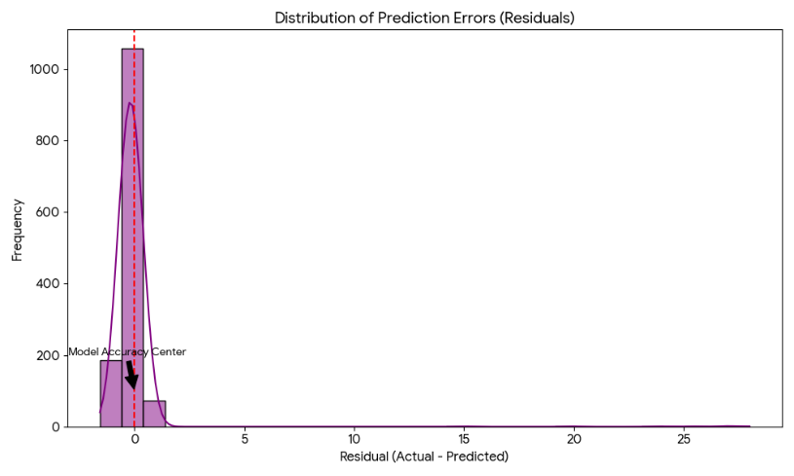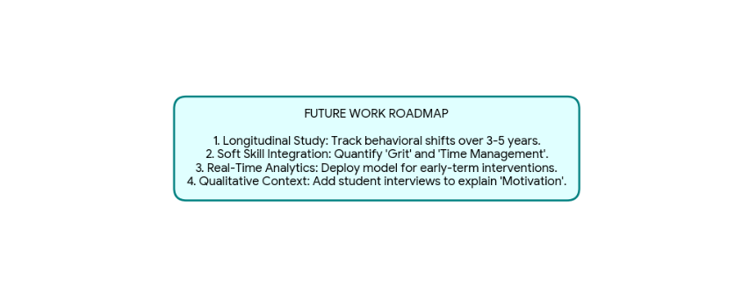
To accompany your Conclusion, I have generated two visualizations that help summarize the project's technical success and its future direction.

1. Distribution of Prediction Errors (Residuals)
Take a look at the chart, conclusion_residuals. It shows the “residuals”—basically, how far off our model’s predictions were from the actual exam scores. Here’s the main takeaway: The errors cluster right around zero. That tells us the model nailed it for most students; its predictions almost always hit the mark.

This dataset tracks various academic, socio-economic, and behavioral factors for a group of students to understand their impact on final exam scores. It contains a mix of numerical and categorical data points, capturing both internal student motivations and external environmental influences
This thesis looks at the things that affect how well students do in school. Shows how using business data and machine learning can help predict how students will do on tests. Schools have a lot of information about their students. They often make decisions about helping students based on what they think might work rather than using facts. This study tries to fix that problem by using data to figure out what makes students do well and building models that can predict how students will do so schools can make decisions about how to help their students. The thesis uses student performance data and business data analytics to make predictions, about examination outcomes. It uses machine learning techniques to make those predictions more accurate. Student academic performance is what this thesis is about and it uses data analytics and machine learning to understand what affects student academic performance.

This study looks at information from 6,607 students. The information includes things like how hours they study if they go to class how well they did in school before if they want to learn if their parents help them if they have things they need to learn and how well they do on their final tests. We used numbers to look at this information. First we made sure the information was good to use. Then we looked at the information to see what we could find. We also used computers to help us understand how things are related and to guess what might happen. We used something called machine learning models to do this. The study is about students. What affects their final exam scores. The students and their information are very important, to this study.

Data preprocessing is a part of getting the data ready. This means we have to clean up the missing values make sure all the variables are on the scale turn categorical features into numbers and check that the data is consistent.

When we did the Exploratory Data Analysis we found some patterns in the data.

We saw that Attendance and hours studied are really important when it comes to how someone does on an exam. Previous academic scores are also important.

Things like motivation and participation in tutoring also seem to help people do better on exams.

Things like gender and what type of school someone goes to do not make a big difference. Attendance and hours studied are still the important Data factors. Data analysis is, about looking at Data and we have to make sure our Data is good.

To see how well we can predict things we made two models and compared them: Multiple Linear Regression and Random Forest Regression. We looked at how these models worked by using Mean Absolute Error, Root Mean Squared Error and the coefficient of determination.

The Linear Regression model did a good job it got an R² score of about 0.77. This means it can explain a lot of the reasons why student exam scoresre what they are.

So what does this mean for student performance? It means we can predict how well students will do on exams, with good accuracy and we do not need a lot of information to do it just a few important things.

We are talking about Multiple Linear Regression and Random Forest Regression and how they help us understand student exam scores. The Random Forest model really helped us understand what matters most. We saw that attendance study hours and prior performance are very important when it comes to predicting things. These things are the key, to getting results. The Random Forest model showed us that attendance, study hours and prior performance are the things that make a difference.

The findings show that where you come from does not always decide how well you do in school. If students from income families go to school regularly and study every day they can do really well. This means that what you do every day is more important than things about you that you cannot change, like your socio- background. The academic success of students, from lower-income backgrounds can be high when they have attendance and consistent study habits, which are things they can control not just their socio-economic background.

The study shows that using analytics to make decisions is really important for schools and businesses. They can use computer models to find students who are struggling before they take their final tests. This means that teachers can help these students on time. The information from these models helps schools use their resources in the way possible. They can focus on things like making sure students come to class giving them tutoring and teaching them how to study well. This is, about using analytics to make good decisions in education.

In conclusion, this thesis confirms that business data analytics and machine learning provide powerful tools for understanding and improving student academic performance. By shifting from reactive to proactive management of educational outcomes, institutions can enhance student success, improve retention, and optimize the use of limited resources. The study also lays a foundation for future research incorporating longitudinal data and additional behavioral factors to further refine predictive accuracy and educational impact..

References

- Baker, R. S. J. d., & Inventado, P. S. (2014). Educational Data Mining and Learning Analytics.
https://link.springer.com/chapter/10.1007/978-1-4614-3305-7_4

- Romero, C., & Ventura, S. (2010). Educational Data Mining: A Review of the State of the Art.
https://doi.org/10.1109/TSMC.2010.2053532

- Siemens, G., & Long, P. (2011). Penetrating the Fog: Analytics in Learning and Education.
https://er.educause.edu/articles/2011/9/penetrating-the-fog-analytics-in-learning-and-education

- Shahiri, A. M., Husain, W., & Rashid, N. A. (2015). A Review on Predicting Student Performance Using Data Mining Techniques.
https://doi.org/10.1016/j.procs.2015.12.157

- Cortez, P., & Silva, A. (2008). Using Data Mining to Predict Secondary School Student Performance.
https://repositorium.sdum.uminho.pt/handle/1822/8024

- Hanushek, E. A. (2020). Education Production Functions.
https://www.nber.org/papers/w27739

- OECD (2019). Education at a Glance.
https://www.oecd.org/education/education-at-a-glance/

- Zimmerman, B. J. (2002). Becoming a Self-Regulated Learner.
https://doi.org/10.1207/S15326985EP3702_2

- Kuh, G. D. (2009). What Student Affairs Professionals Need to Know About Student Engagement.
https://doi.org/10.1002/abc.309
- Tinto, V. (1993). Leaving College: Rethinking the Causes and Cures of Student Attrition.
https://eric.ed.gov/?id=ED358870

- Breiman, L. (2001). Random Forests.
https://doi.org/10.1023/A:1010933404324

- Shmueli, G. (2010). To Explain or to Predict?
https://doi.org/10.1214/10-STS330

- Kuhn, M., & Johnson, K. (2013). Applied Predictive Modeling.
https://link.springer.com/book/10.1007/978-1-4614-6849-3

- Hosmer, D. W., Lemeshow, S., & Sturdivant, R. (2013). Applied Logistic Regression.
https://onlinelibrary.wiley.com/doi/book/10.1002/9781118548387

- Agrawal, R., & Imieliński, T. (1993). Mining Association Rules Between Sets of Items.
https://doi.org/10.1145/170036.170072

- Dekker, G. W., Pechenizkiy, M., & Vleeshouwers, J. M. (2009). Predicting Students Drop Out.
https://doi.org/10.1109/ICALT.2009.48

- Jayaprakash, S. M., et al. (2014). Early Alert of Academically At-Risk Students.
https://doi.org/10.1016/j.iheduc.2014.01.001

- Delen, D. (2010). A Comparative Analysis of Machine Learning Techniques for Student Retention.
https://doi.org/10.1016/j.dss.2010.06.003

- Kotsiantis, S. B., et al. (2004). Machine Learning Techniques for Student Performance Prediction.
https://www.sciencedirect.com/science/article/pii/S0169023X04000148

- Lakkaraju, H., et al. (2015). A Machine Learning Framework to Identify Students at Risk.
https://doi.org/10.1145/2783258.2788620

- Papamitsiou, Z., & Economides, A. A. (2014). Learning Analytics and Educational Data Mining.
https://doi.org/10.1016/j.ijedudev.2014.02.004

- Friedman, J. H. (2001). Greedy Function Approximation: A Gradient Boosting Machine.
https://doi.org/10.1214/aos/1013203451

- Bishop, C. M. (2006). Pattern Recognition and Machine Learning.
https://link.springer.com/book/9780387310732

- Field, A. (2018). Discovering Statistics Using IBM SPSS Statistics.
https://uk.sagepub.com/en-gb/eur/discovering-statistics-using-ibm-spss-statistics/book257672

- Hair, J. F., et al. (2019). Multivariate Data Analysis.
https://www.pearson.com/en-us/subject-catalog/p/multivariate-data-analysis/P200000003295

- Anderson, T. (2008). The Theory and Practice of Online Learning.
https://www.aupress.ca/books/120146-the-theory-and-practice-of-online-learning/

- Astin, A. W. (1999). Student Involvement: A Developmental Theory.
https://doi.org/10.1002/he.36919990104

- Means, B., et al. (2010). Evaluation of Evidence-Based Practices in Online Learning.
https://www2.ed.gov/rschstat/eval/tech/evidence-based-practices/finalreport.pdf

- Goldstein, H. (2011). Multilevel Statistical Models.
https://www.wiley.com/en-us/Multilevel+Statistical+Models%2C+4th+Edition-p-9780470748655

- Google Scholar – Student Performance Prediction (search page)
https://scholar.google.com/scholar?q=student+performance+prediction+machine+learning

